Standard Operating Procedure
Hydrazine

This is an SOP template and is not complete until: 1) Lab Specific information is entered into the box below 2) Lab Specific information is added to the various sections, 3) completed SOP has been approved by the PI, and 4) completed SOP has been signed and dated by all relevant lab personnel.
Keep a copy and in your lab safety shared folder or binder.
Department: | Click here to enter text.
SOP Preparation Date: | Click here to enter a date. | SOP Approval Date: |  | Click here to enter a date.
Principal Investigator: | Click here to enter text.
Lab Manager Name: | Click here to enter text.
Laboratory Phone: | Click here to enter text. |  | Office Phone: | Click here to enter text.
Emergency Contact: | Click here to enter text. |  | Contact Phone: | Click here to enter text.
Laboratory locations covered by this SOP (building / room number):
Click here to enter text.

Type of SOP: | ☐ | Process | ☒ | Hazardous Chemical | ☐ | Hazardous Class

Purpose
Hydrazine is mainly used as a foaming agent in preparing polymer foams, but significant applications also include its uses as a precursor to polymerization catalysts and pharmaceuticals. Additionally, hydrazine is used in various rocket fuels and to prepare the gas precursors used in air bags (Sodium azide, the gas-forming agent in air bags, is produced from hydrazine by reaction with sodium nitrite). Hydrazine is used within both nuclear and conventional electrical power plant steam cycles to control concentrations of dissolved oxygen in an effort to reduce corrosion. Hydrazine is a useful building block in organic synthesis of pharmaceuticals and pesticides. It is used as an oxygen scavenger and corrosion inhibitor in water boilers and heating systems. It is also used to reduce metal salts and oxides to the pure metals in electroless nickel plating and plutonium extraction from nuclear reactor waste. Some color photographic processes also use a weak solution of hydrazine as a stabilizing wash, as it scavenges dye coupler and unreacted silver halides. In addition, a semiconductor deposition technique using hydrazine has recently been demonstrated with possible application to the manufacture of thin-film transistors used in Liquid Crystal Displays (LCD systems)

Physical and Chemical Properties / Definition of Chemical Group
CAS: | 302-01-2 | 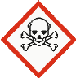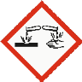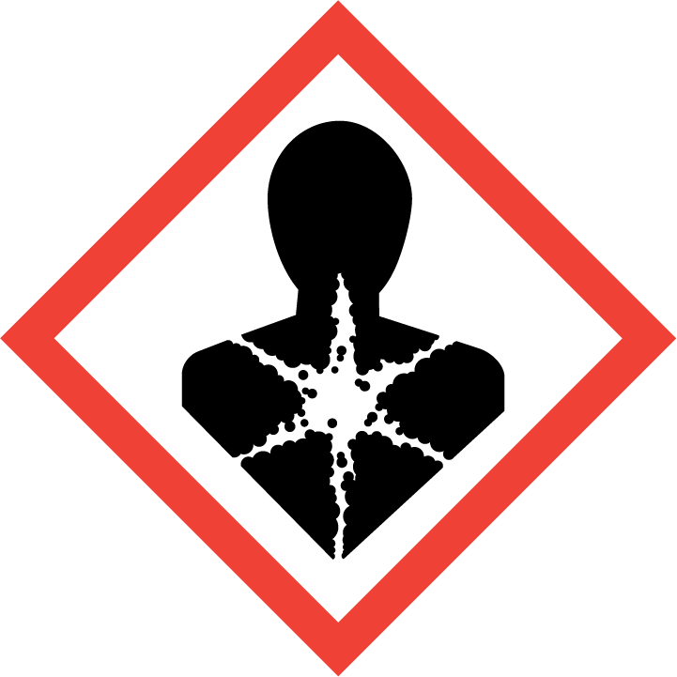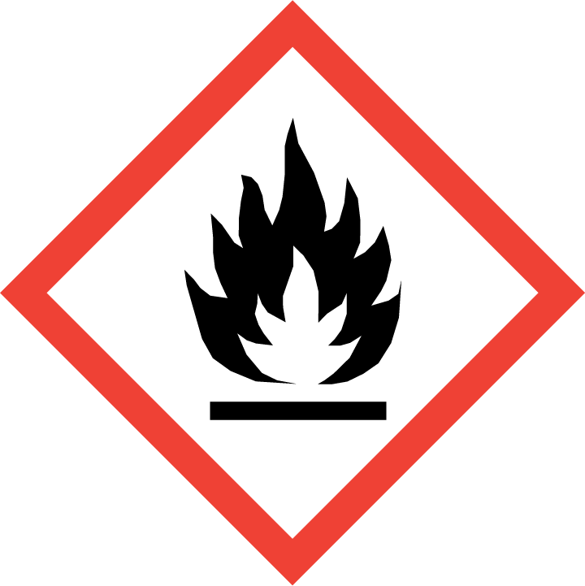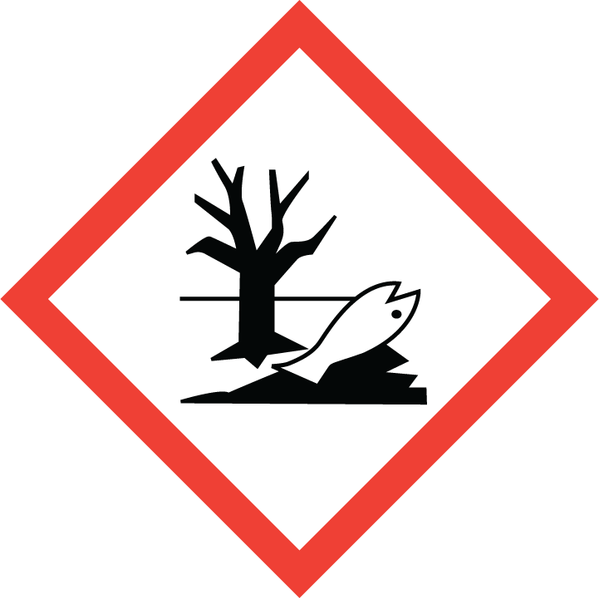
Class: | Toxic, Corrosive, Carcinogen, Combustible liquid
Molecular Formula: | N₂H₄
Form (physical state): | Liquid
Color: | Colorless
Boiling Point: | 113 ºC

Potential Hazards / Toxicity
Potential Health Effects
Target Organs: | Nerves, Blood, Liver, Kidney, Lungs
Inhalation: | Toxic if inhaled. Material is extremely destructive to the tissue of the mucous membranes and upper respiratory tract.
Skin: | May be fatal if absorbed through skin. Causes skin burns.
Eyes: | Causes eye burns.
Ingestion: | Toxic if swallowed.

HEIRARCHY OF CONTROLS:
Engineering Controls
Lab Specific Engineering Controls (Add your lab’s specific engineering controls in this section).
Click here to enter text.

Handle inside a glove box (under an inert atmosphere- preferably under Nitrogen).

Administrative Controls
Lab Specific Administrative Controls (Add your lab’s specific administrative controls in this section).
Click here to enter text.

Adhere to the processes outlined in this SOP.

Personal Protective Equipment (PPE)
Lab Specific PPE requirements (Add your lab specific PPE requirements in this section).
Click here to enter text.

Hand Protection
Handle with gloves. Neoprene or nitrile gloves are recommended.

NOTE: Consult with your preferred glove manufacturer to ensure that the gloves you plan on using are compatible with Hydrazine.
Refer to glove selection chart from the links below:
http://www.ansellpro.com/download/Ansell_8thEditionChemicalResistanceGuide.pdf
OR
http://www.allsafetyproducts.biz/page/74172
OR
http://www.showabestglove.com/site/default.aspx

Eye Protection

- Wear chemical splash goggles or a face shield to protect from splash hazards and chemical vapors.

Skin & Body Protection

- Fire/flame resistant lab coat (100% cotton based)
- Full-length pants
- Closed-toe rubber or leather shoes
- Safety goggles (if splash hazard is present)

Respiratory Protection
Where risk assessment shows air-purifying respirators are appropriate use a full-face respirator with multi-purpose combination (US) or type ABEK (EN 14387) respirator cartridges as a backup to engineering controls. If the respirator is the sole means of protection, use a full-face supplied air respirator. Use respirators and components tested and approved under appropriate government standards such as NIOSH (US) or CEN (EU).

Respirators should be used only under any of the following circumstances:
- As a last line of defense (i.e., after engineering and administrative controls have been exhausted).
- When Permissible Exposure Limit (PEL) has exceeded or when there is a possibility that PEL will be exceeded. Contact RMS to schedule air monitoring.
- Regulations require the use of a respirator.
- An employer requires the use of a respirator.
- There is potential for harmful exposure due to an atmospheric contaminant (in the absence of PEL).
- As PPE in the event of a chemical spill clean-up process.

Lab personnel intending to use/wear a respirator mask must be trained and fit-tested. This is a regulatory requirement.
https://riskmanagement.nd.edu/safety/occupational-health/respiratory-protection-plan/

Hygiene Measures

Avoid contact with skin, eyes, and clothing. Wash hands before breaks and immediately after handling the product.

Special Storage & Handling Requirements

Storage
- Ensure the container is tightly closed at all times.
- Keep in a dry, well-ventilated area away from incompatible materials and environments.
- Containers which are opened must be carefully resealed and kept upright to prevent leakage.
- Keep away from heat, sparks, and flame.
- Keep away from sources of ignition.
- Keep away from acids and moisture.
- Do not store in direct sunlight or strong incandescent light.
- Storage under a nitrogen blanket is recommended OR inside a glove box (under inert atmosphere).
- Isolate from oxidizing materials and acids.
- All hydrazine containers must be stored using secondary container (tray/tub) with proper signage/caution label.
- Hazard communication: warning/caution label is required on each hydrazine container, secondary containment, and designated storage cabinets/areas. Warning/caution label must state the following: “CARCINOGEN / CANCER HAZARD or SUSPECT CANCER AGENT & REPRODUCTIVE TOXIN”

Handling
- The lab where the material is being handled has an approved / certified emergency eyewash and safety shower.
- Ensure you are wearing the following minimum PPE: tightly fitting safety goggles and face shield, fire/flame resistant lab coat, full length pants, close-toe rubber or leather shoes, Neoprene or nitrile gloves.
- Lab emergency contact information must be readily posted. Easy access to a cellular phone or landline is readily available.
- Ground and bond containers when transferring material (i.e., if in a metal container). For safety reasons, transfer from glass to glass container using proper techniques (often purged with nitrogen).
- Never add water to this product.
- Avoid shock and friction.
- Use spark-proof tools and explosion-proof equipment.
- Keep away from heat, sparks, or open flames.
- Avoid contact with eyes, skin, or clothing.
- Empty containers retain product residue (liquid and/or vapor) and can be dangerous.
- Avoid ingestion or inhalation.
- Do not pressurize, cut, weld, braze, solder, drill, grind, or expose empty containers to heat, sparks, or open flames.
- Use only with adequate ventilation or respiratory protection.
- Take measures to prevent the buildup of electrostatic charge.

EMERGENCY ACTION PLAN (EAP):
Lab Specific EAP (Add your lab’s specific emergency action plan variances in this section).
Click here to enter text.

First Aid Procedures

If inhaled… Move to fresh air. If the person is not breathing, give artificial respiration. DO NOT use mouth to mouth resuscitation. If breathing is difficult, give oxygen. Call 911 from a campus phone or (574) 631-5555 from a cell phone to report exposure to Notre Dame Police Dept. (NDPD) dispatch.

In case of skin contact… Remove all contaminated clothing. Immediately (within seconds) flush affected area for FIFTEEN (15) minutes. Call 911 from a campus phone or (574) 631-5555 from a cell phone to report exposure to Notre Dame Police Dept. (NDPD) dispatch.

In case of eye contact… Remove any contact lenses. Use nearest emergency eyewash immediately for at least 15 minutes. DO NOT allow victim to rub eyes or keep eyes closed. Call 911 from a campus phone or (574) 631-5555 from a cell phone to report exposure to Notre Dame Police Dept. (NDPD) dispatch.

If swallowed… DO NOT INDUCE VOMITING. Give large quantities of milk (preferable) or water. Never give anything by mouth to an unconscious person. Call 911 from a campus phone or (574) 631-5555 from a cell phone to report exposure to Notre Dame Police Dept. (NDPD) dispatch.

Spill and Accident Procedure

Personal precautions
Wear respiratory protection. Avoid breathing vapors, mist or gas. Ensure adequate ventilation. Remove all sources of ignition. Evacuate personnel to safe areas. Do not attempt clean-up without minimum PPE. Beware of vapors accumulating to form explosive concentrations. Vapors can accumulate in low areas.

Environmental precautions
Prevent further leakage or spillage – if safe to do so. Do not allow product to enter drains. Discharge into the environment must be avoided.

Methods and materials for containment and clean-up
Consider material compatibility prior to clean-up. Verify spill kit is available.

- Immediately assess amount spilled, follow Lab Specific Emergency Action Plan procedures for hazardous materials incidents.
- If a chemical exposure has occurred, a fellow lab worker shall call 911 from a campus line or 574-631-5555 from a cell phone to report exposure to Notre Dame Police Dept. (NDPD) dispatch.
- Don compatible gloves and other protective PPE if not already being worn.
- Secure / restrict access to the area of the spill to prevent spread of the chemical.
- Use the available spill kit to stop and contain the spill. Bag the collected material.
- Label and tag as hazardous waste and submit a pick-up request to RMS using the online Chemical Discard Tag form.

Decontamination / Waste Disposal Procedure

Waste Labeling Requirements
- Label waste container with the term “Hazardous Waste- Hydrazine” and “Toxic” (or toxic GHS pictogram) to all hydrazine waste containers prior to the first drop of waste being added to the container.
Store waste
- Store hazardous waste in closed containers, in secondary containment and in a designated storage location.
- Double-bag dry waste using sealable transparent bags.
- Waste must be under the control of the person generating and disposing of it.

Dispose of waste
- Dispose of regularly generated chemical waste within 90 days.
- Use the online Chemical Discard Tag form to request a pickup.
- Contact RMS at (574) 631-5037 for waste-related questions.

Protocol / Procedure

Lab Specific Procedures (Add your lab’s specific procedures in this section).
Click here to enter text.

IMPORTANT NOTE: Any deviation from this SOP requires advance PI approval.

Documentation of Training

- Prior to conducting any work with this material, Principal Investigator or designee must provide to his/her laboratory personnel specific to the hazards involved in working with this substance, work area decontamination, and emergency procedures.
- The Principal Investigator must provide his/her laboratory personnel with a copy of this SOP and a copy of the Material Safety Data Sheet (SDS) provided by the manufacturer available in MSDSOnline.
- The Principal Investigator must ensure that his/her laboratory personnel have attended appropriate/required laboratory safety training or refresher training within the last one year.

I have read and understand the content of this SOP.

Employee Name | Signature | Date
Click here to enter text. |  | Click here to enter a date.
Click here to enter text. |  | Click here to enter a date.
Click here to enter text. |  | Click here to enter a date.
Click here to enter text. |  | Click here to enter a date.
Click here to enter text. |  | Click here to enter a date.
Click here to enter text. |  | Click here to enter a date.
Click here to enter text. |  | Click here to enter a date.
Click here to enter text. |  | Click here to enter a date.
Click here to enter text. |  | Click here to enter a date.
Click here to enter text. |  | Click here to enter a date.
Click here to enter text. |  | Click here to enter a date.
Click here to enter text. |  | Click here to enter a date.
Click here to enter text. |  | Click here to enter a date.
Click here to enter text. |  | Click here to enter a date.
Click here to enter text. |  | Click here to enter a date.
Click here to enter text. |  | Click here to enter a date.
Click here to enter text. |  | Click here to enter a date.
Click here to enter text. |  | Click here to enter a date.
Click here to enter text. |  | Click here to enter a date.
Click here to enter text. |  | Click here to enter a date.
Click here to enter text. |  | Click here to enter a date.
Click here to enter text. |  | Click here to enter a date.
Click here to enter text. |  | Click here to enter a date.
Click here to enter text. |  | Click here to enter a date.
Click here to enter text. |  | Click here to enter a date.
Click here to enter text. |  | Click here to enter a date.
Click here to enter text. |  | Click here to enter a date.
Click here to enter text. |  | Click here to enter a date.

