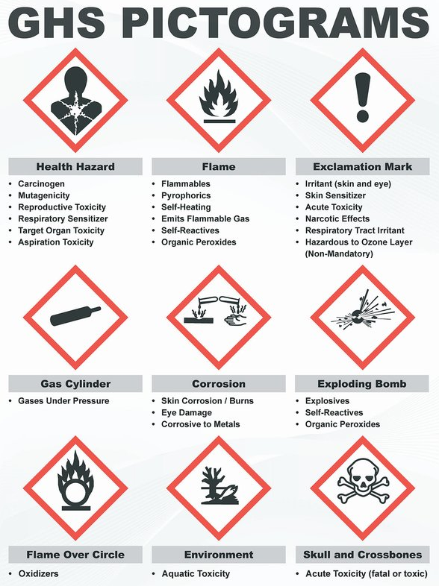

GHS02 FLAMMABLE:
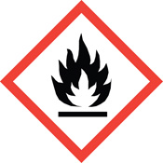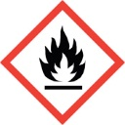

GHS02 FLAMMABLE:

GHS05 CORROSIVE:
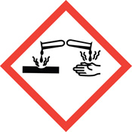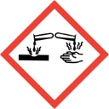

GHS05 CORROSIVE:

GHS03 OXIDIZING / OXIDIZER:
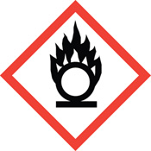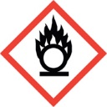
GHS03 OXIDIZING / OXIDIZER:

GHS06 TOXIC:
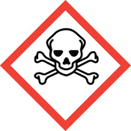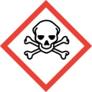
GHS06 TOXIC:

GHS04 COMPRESSED GAS / CYLINDER:
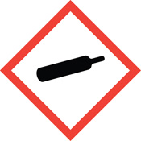
GHS04 COMPRESSED GAS / CYLINDER:

GHS08 HEALTH HAZARD:
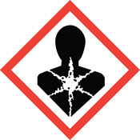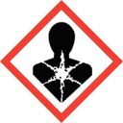
GHS08 HEALTH HAZARD:

GHS09 ENVIRONMENTAL / AQUATIC LIFE TOXICITY / HAZARD:
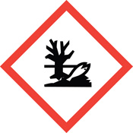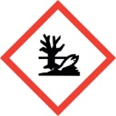
GHS09 ENVIRONMENTAL / AQUATIC LIFE TOXICITY / HAZARD:

GHS01 EXPLOSIVE:
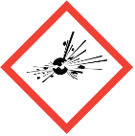
GHS01 EXPLOSIVE:
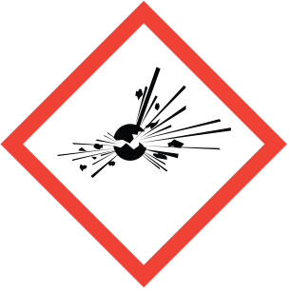

GHS07 HARMFUL:

GHS07 HARMFUL:
